

**Lab 8.1.2.4 - Configuring Basic DHCPv4 on a Router**

## Topology

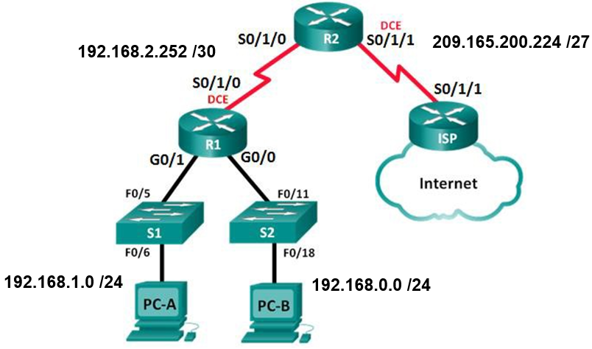

**Addressing Table**

|  |  |  |  |  |
| --- | --- | --- | --- | --- |
| **Device** | **Interface** | **IP Address** | **Subnet Mask** | **Default Gateway** |
| **R1** | **G0/0** | **192.168.0.1** | **255.255.255.0** | **N/A** |
|  | **G0/1** | **192.168.1.1** | **255.255.255.0** | **N/A** |
|  | **S0/1/0 (DCE)** | **192.168.2.253** | **255.255.255.252** | **N/A** |
| **R2** | **S0/1/0** | **192.168.2.254** | **255.255.255.252** | **N/A** |
|  | **S0/1/1 (DCE)** | **209.165.200.226** | **255.255.255.224** | **N/A** |
| **ISP** | **S0/1/1** | **209.165.200.225** | **255.255.255.224** | **N/A** |
| **PC-A** | **NIC** | **DHCP** | **DHCP** | **DHCP** |
| **PC-B** | **NIC** | **DHCP** | **DHCP** | **DHCP** |

**Objectives**

**Part 1: Build the Network and Configure Basic Device Settings**

**Part 2: Configure a DHCPv4 Server and a DHCP Relay Agent**

**Background / Scenario**

The **Dynamic Host Configuration Protocol (DHCP) is a network protocol that lets network administrators manage and automate the assignment of IP addresses.** Without DHCP, the administrator must manually assign and configure IP addresses, preferred **DNS servers**, and **default gateways**. As the network grows in size, this becomes an administrative problem when devices are moved from one internal network to another.

In this scenario, the company has grown in size, and the network administrators can no longer assign IP addresses to devices manually. Your job is to configure the **R2 router to assign IPv4 addresses on two different subnets connected to router R1.**

1. Build the Network and Configure Basic Device Settings

In Part 1, you will set up the network topology and configure the routers and switches with basic settings, such as passwords and IP addresses. You will also configure the IP settings for the PCs in the topology.

* 1. Configure basic settings for each router.
     1. Console into the router and enter global configuration mode.
     2. Copy the following basic configuration and paste it to the running-configuration on the router.

**no ip domain-lookup**

**service password-encryption**

**enable secret class**

**banner motd #**

**Unauthorized access is strictly prohibited. #**

**line con 0**

**password cisco**

**login**

**logging synchronous**

**line vty 0 4**

**password cisco**

**login**

* + 1. Configure the host name as shown in the topology.
    2. Configure the IPv4 addresses on the router as shown in the topology.
    3. Set the DCE serial interfaces with a clock rate of **128000**.
  1. Configure dynamic, default, and static routing on the routers.
     1. Configure **RIPv2** for **R1**.

R1(config)# **router rip**

R1(config-router)# **version 2**

R1(config-router)# **network 192.168.0.0**

R1(config-router)# **network 192.168.1.0**

R1(config-router)# **network 192.168.2.252 se pone automáticamente 192.168.2.0**

R1(config-router)# **no auto-summary**

* + 1. Configure **RIPv2** and a default route to the **ISP** on **R2**.

R2(config)# **router rip**

R1(config-router)# **version 2**

R2(config-router)# **network 192.168.2.252 se pone automáticamente 192.168.2.0**

R2(config-router)# **default-information originate**

R1(config-router)# **no auto-summary**

R2(config-router)# **exit**

R2(config)# **ip route 0.0.0.0 0.0.0.0 209.165.200.225**

* + 1. Configure a  **static route** on **ISP** to reach the networks on the **R1** and **R2** routers.

ISP(config)# **ip route 192.168.0.0 255.255.252.0 209.165.200.226**

* 1. Verify network connectivity between the routers.

If any pings between routers fail, correct the errors before proceeding to the next step. Use **show ip route** and **show ip interface brief** to locate possible issues.

* 1. Verify the host PCs are configured for DHCP.

1. Configure a DHCPv4 Server and a DHCP Relay Agent

To automatically assign address information on the network, you will configure **R2** as a **DHCPv4 server** and **R1 as a DHCP relay agent.**

* 1. Configure DHCPv4 server settings on router R2.

On **R2**, you will configure a **DHCP address pool** for each of the **R1 LANs**. Use the pool name **R1G0** for the **G0/0 LAN** and **R1G1** for the **G0/1 LAN**. You will also configure the addresses to be excluded from the address pools. Best practice dictates that excluded addresses be configured first, to guarantee that they are not accidentally leased to other devices.

Exclude **the first 9 addresses** in each **R1 LAN** starting with **.1**. All other addresses should be available in the DHCP address pool. Make sure that each DHCP address pool includes a default gateway and a DNS server (209.165.200.225).

On the lines below, write the commands necessary for configuring DHCP services on router R2, including the **DHCP-excluded addresses** and the **DHCP address pools**.

**R2(config)# ip dhcp excluded-address 192.168.1.1 192.168.1.9**

**R2(config)# ip dhcp excluded-address 192.168.0.1 192.168.0.9**

**R2(config)# ip dhcp pool R1G1**

**R2(dhcp-config)# network 192.168.1.0 255.255.255.0**

**R2(dhcp-config)# default-router 192.168.1.1**

**R2(dhcp-config)# dns-server 209.165.200.225**

**R2(dhcp-config)# exit**

**R2(config)# ip dhcp pool R1G0**

**R2(dhcp-config)# network 192.168.0.0 255.255.255.0**

**R2(dhcp-config)# default-router 192.168.0.1**

**R2(dhcp-config)# dns-server 209.165.200.225**

On **PC-A** or **PC-B**, open a command prompt and enter the **ipconfig /all** command. Did either of the host PCs receive an IP address from the DHCP server? Why?

____________________________________________________________________________________

**A DHCP relay agent is any host that forwards DHCP packets between clients and servers.**

* 1. Configure R1 as a DHCP relay agent.

Configure **IP helper** addresses on **R1** to forward all **DHCP requests** to the **R2 DHCP server**.

On the lines below, write the commands necessary to configure **R1 as a DHCP relay agent** for the **R1 LANs**.

**R1(config)# int g0/0**

**R1(config-if)# ip helper-address 192.168.2.254**

**R1(config-if)# exit**

**R1(config)# int g0/1**

**R1(config-if)# ip helper-address 192.168.2.254**

* 1. Record IP settings for PC-A and PC-B.

On **PC-A** and **PC-B**, issue the **ipconfig /all** command to verify that the PCs have received IP address information from the **DHCP server on R2**. Record the IP and MAC address for each PC.

_______________________________________________________________________________________

_______________________________________________________________________________________

Based on the **DHCP pool** that was configured on **R2**, what are the first available IP addresses that **PC-A** and **PC-B** can lease?

_______________________________________________________________________________________

* 1. Verify DHCP services and address leases on R2.
     1. On **R2**, enter the **show ip dhcp binding** command to view DHCP address leases.

Along with the IP addresses that were leased, what other piece of useful client identification information is in the output?

__________________________________________________________________________________

* + 1. On R2, enter the **show ip dhcp pool** command to view the DHCP pool settings.

In the output of the **show ip dhcp pool** command, what does the current **index** refer to?

_______La siguiente dirección IP disponible a prestar o arrendar.

_____________________________________________________________________________

On **R2**, enter the **show run | begin dhcp** command to view the DHCP configuration in the running configuration.

* + 1. On **R1**, enter the **show run | begin interface GigabitEthernet0/0** command and **show run | begin interface GigabitEthernet0/1** to view the DHCP relay configuration in the running configuration file.

1. Reflection

What do you think is the benefit of using DHCP relay agents instead of multiple routers acting as DHCP servers?

_______________________________________________________________________________________

_______________________________________________________________________________________

_______________________________________________________________________________________

_______________________________________________________________________________________